**Search Features:** The NetView Insight Search includes various features to help you sort through and narrow down your results.

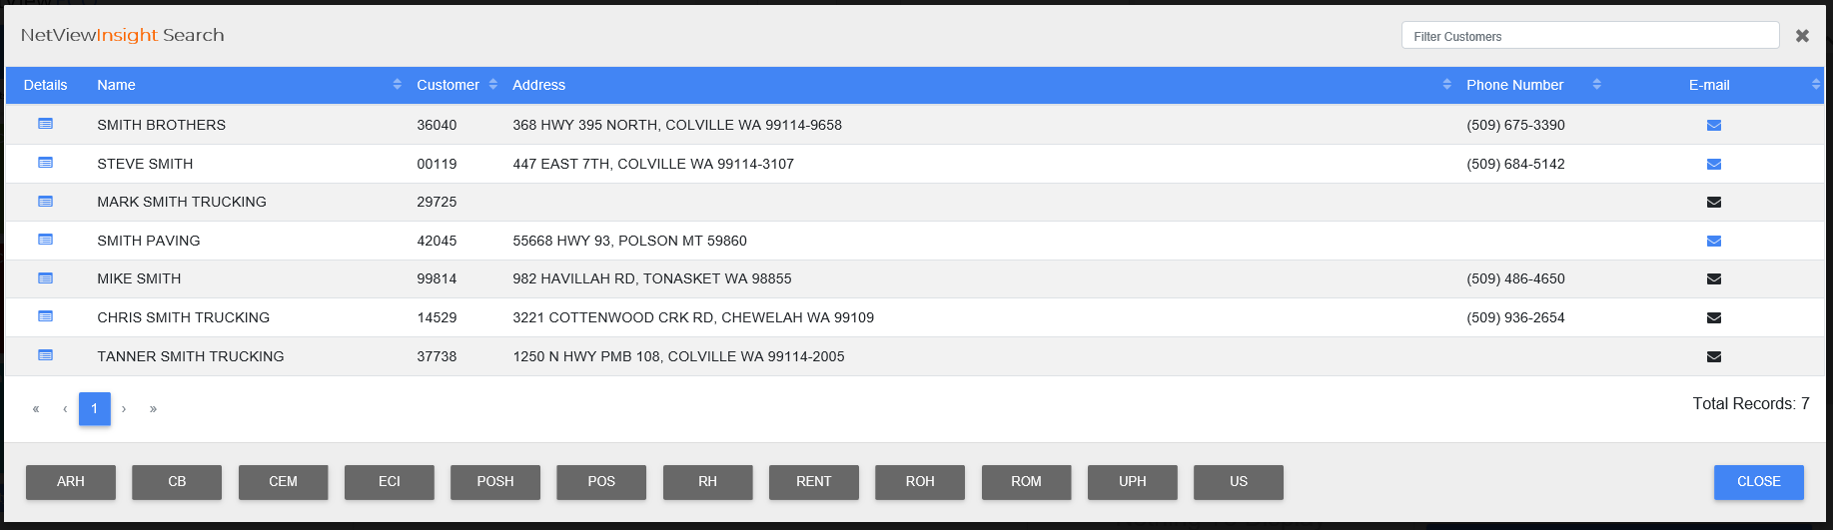

**Sortable Headers:** By clicking the column headers, you can sort the columns in a certain order.  NOTE: The feature can only sort by one header at a time.  The moment you click a different heading, the results will only sort by the new selected heading.

**Switching Pages:** The page numbers are listed below the lower-right-hand corner.  The square representing the current page will be colored blue.  The page list shows how many pages of results there are and allows you to move between pages.

Single Page Scroll: Click the single arrows to move left and right a single page. If one of the arrows is grey, then you cannot scroll forward or back from that page.

First & Last Scroll: The First & Last scroll buttons are the double arrows at both ends of the page list.  They allow you to move from any results page to either the very first results page or the very last.

* Click on the **left**-pointing double arrows to reach the **first** page.
* Click on the **right**-pointing double arrows to reach the **last** page.

**Page Buttons:** You can also switch between pages by clicking on the page numbers listed between the arrow buttons.  For example, to go to page 2, click on “2.”

**Filter Customers:** The Filter Customers field is located in the upper right-hand corner. It allows you to further narrow down your results by typing information into the bar, like part of a name or the last 4 digits of a phone number.